Name\Surname: İrem AŞUTKALIOĞLU Date: 19/10/2020

ID: 2284123 SECTION: 2

**THE MICROSCOPE**

**1-) INTRODUCTION:**

Microscope’s resolution is explained that shortest distance between two points on a specimen that can still be distinguished by observer or camera system as separate entities (Resolution, 2020). Limit of resolution is that a measure of the ability of the objective lens to separate in the image adjacent details that are present in the object (DoITPoMS - TLP Library Optical Microscopy and Specimen Preparation - Resolution & Imaging, 2020). Limit of resolution and resolution work in an opposite way. When one of them is increased, the other one is decreased. The depth of field is defined as depth of field is determined by the distance from the nearest object plane in focus to that of the farthest plane also simultaneously in focus (Depth of Field and Depth of Focus, 2020).

**2-) METHOD:**

Using Microscope:

When we are going to take the microscope where it's been, we should carry out its arm. Also, when we carry, we put our hands to under the foot. If a microscope does not carry out in that way, it can be broken. Therefore, we must be careful about this. After we carry the microscope, we clean if it is not clean. If it is clean, we can plug in, and the microscope can be started. Then, we turn out the microscope. Ocular lenses are set to sixty-four. Then condenser lenses are brought to stage level. The slide is placed between stage clips on the stage. We should start with the lowest magnification(4X). Then, we can find the image while using coarse adjustment. After that, while using fine adjustment, we can focus on the image, and we can see a sharper image. Then, we can pass the second magnification which is the 10X. We repeat the same steps in that magnification. After that, we pass the 10X and turn the other which is 40X. As 10X, we should repeat these steps. While we pass to 100X, we use immersion oil because if we do not use this oil, lenses or slide can be broken and our sample can be deteriorated. In high magnification, we should not use the coarse knob. We just use fine knob. After we use the microscope, microscope have to clean, and stage have to be lowest position and lowest power.

The Field of View:

In the lowest magnification, we focus with fine and coarse adjustment knob by the metric marking are clear. We should use millimetric paper and calculate the radius at lower magnification. We must know the magnification and field number of the microscope’s lens which is used currently (Depth of Field and Depth of Focus, 2020). To calculate the field of view:

FOVlow x Maglow = FOVhi x Maghi

And

area of cycle = π x (radius)2

**3-) RESULT:**

3.1-) The Microscope:

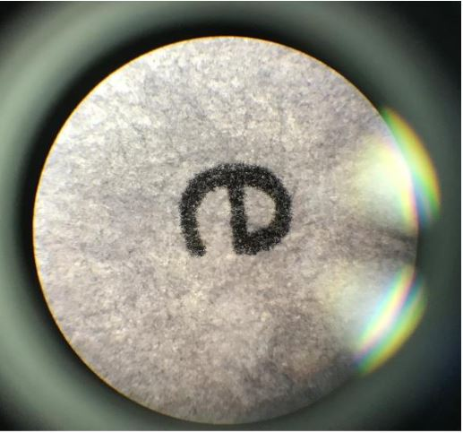 **Image 3.1.1: The letter at 4X magnification**

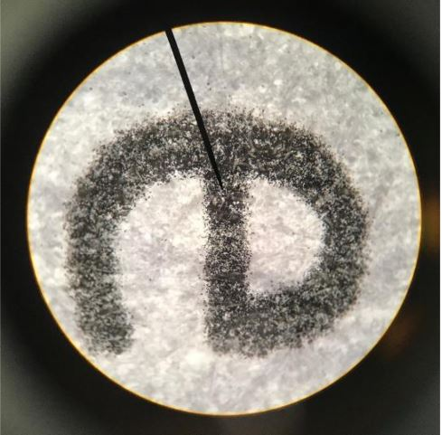 **Image 3.1.2: The letter at 10X magnification**

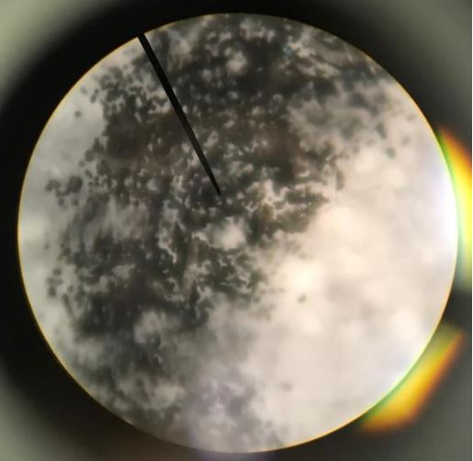 **Image 3.1.3: The letter at 40X magnification**

3.2-) FOV calculation:

|  |  |  |  |  |  |
| --- | --- | --- | --- | --- | --- |
| **Objective Power** | **Objective Magnification** | **Ocular Magnification** | **Total Magnification** | **FOV diameter(mm)** | **FOV area (mm2)** |
| **Low** | **4X** | **10X** | **40X** | **2mm** | **4 *π*** |
| **Medium** | **10X** | **10X** | **100X** | **1mm** | ***π*** |
| **High** | **40X** | **10X** | **400X** | **0.5mm** | **1/4 *π*** |

**4- DISCUSSION:**

We observe that the e letter in the microscope. Firstly, we look from the ocular lenses and see the e letter at 4X magnification power. While rays from the light source move on the condenser lens, they reach the stage and then, after this image reach the objective lens, it looks like inversely. If additional optical element does not exist, image looks inversely. However, we see the image in the right way. Therefore, we can see the image in the right position. Now, the e letter is looked turn right and we see the image that position. When magnification is increased, the e letter is looked bigger. Also, it has more detail. The structure of ink is looked in more detail at 10X and 40X magnification. The area that we see is decreased to 40X magnification because we see the image in more detail and bigger and we see just a certain part of letter e.

If we compare to 40X and 100X magnification, we realize the differentiation between them. We use the index of air in the numerical aperture at 40X magnification but in the 100X magnification, numerical aperture is different, and it is more. When this index is increased, N x A is increased. Therefore, limit of resolution is decreased, and resolution is increased. As a result of that, the image with 100X magnification has low limit of resolution and high-resolution index. When we observe the difference of field of view between 40X and 100X magnification, we realize that more area is seen at the 40X magnification. However, few amounts of area are seen at 100X magnification. The image which is 100X magnification contains more detail. If we analyze the images which have different magnification index, we realize 100X magnification provide sharper image. It shows the area, which is smaller, sharper than the image which has 40X magnification.

Compound microscope provide that we see two-dimensional image but dissecting(stereo) microscope allow us to see three- dimensional image. Dissecting microscope is more effective because of this feature. When we look the other feature, we realize that both have different effective features. For example, because of using two set lenses compound microscope has higher magnification. Also, compound microscope provide magnification between 40X-1000X. Stereo microscope provide magnification between 10X-40X. When we use the stereo microscope, the stage which is used to put our samples is bigger than compound microscope. Therefore, we observe big samples in the stereo microscope.

**5-) REFERANCES:**

--Nikon’s MicroscopyU. 2020. *Depth Of Field And Depth Of Focus*. [online] Available at: <https://www.microscopyu.com/microscopy-basics/depth-of-field-and-depth-of-focus#:~:text=Just%20as%20in%20classical%20photography,measured%20in%20units%20of%20microns.> [Accessed 21 October 2020].

--Doitpoms.ac.uk. 2020. *Doitpoms - TLP Library Optical Microscopy And Specimen Preparation - Resolution & Imaging*. [online] Available at: <https://www.doitpoms.ac.uk/tlplib/optical-microscopy/resolution.php#:~:text=The%20limit%20of%20resolution%20(or,just%20resolved%20in%20the%20image.> [Accessed 21 October 2020].

-- Sciencing. 2020. *How To Calculate The Field Of View In A Microscope*. [online] Available at: <https://sciencing.com/calculate-field-microscope-7603588.html> [Accessed 22 October 2020].

-- Nikon’s MicroscopyU. 2020. *Resolution*. [online] Available at: <https://www.microscopyu.com/microscopy-basics/resolution#:~:text=The%20resolution%20of%20an%20optical,camera%20system%20as%20separate%20entities.> [Accessed 21 October 2020].

-- Microscopeworld.com. 2020. *What Is A Compound Microscope And What Is A Compound Microscope Used For?*. [online] Available at: <https://www.microscopeworld.com/p-3470-what-is-a-compound-microscope.aspx#:~:text=A%20compound%20microscope%20is%20an,provides%20a%20three%2Ddimensional%20image.> [Accessed 24 October 2020].